Year 11 Human Biology –

**Inheritance, Variation and Mutations** /58

Name:________________________

**PART A: MULTIPLE CHOICE**

1. To display recessive characteristics you must have:
2. Have both alleles recessive.
3. Have both alleles dominant.
4. One recessive allele and one dominant allele.
5. Physical characteristics due to the genotype.
6. Choose the **incorrect** statement regarding the chromosomes.
   1. Human beings have 46 chromosomes in a normal body cell.
   2. One pair of chromosomes control the formation of asexual characteristics.
   3. In humans there are two types of sex chromosomes.
   4. The 23rd pair of chromosomes are the sex chromosomes.
7. Choose the **incorrect** statement regarding mitochondrial DNA:
   1. It is found only in the ova.
   2. It is inherited from the mother.
   3. It is inherited from the father.
   4. It is located in the mitochondria.
8. Choose the **incorrect** statement regarding sex chromosomes.
   1. The X chromosome is much bigger than the Y chromosome.
   2. Some genes found on the X chromosome are not found on the Y chromosome.
   3. A female has only one copy of all the genes on the X chromosome.
   4. A male has only one copy of certain genes on the X chromosome.
9. A person with Rh antibodies:
   1. Is said to be Rh positive.
   2. Can produce anti-Rh antibody.
   3. Is said to be Rh negative.
   4. Can produce anti-Rh antigens.

**PART B: SHORT ANSWER**

1)Fill in the table below. (4 marks)

|  |  |  |
| --- | --- | --- |
| Blood group | Antigens on red blood cells | Antibodies in plasma |
| A |  |  |
| B |  |  |
| AB |  |  |
| O |  |  |

2) A homozygous male tall pea plant is crossed with a homozygous female short pea plant. What are the possible offspring? Show full working out and include genotypes, phenotypes and percentages.

T=tall, t=short. (5 marks)

3) Fill in the table below. (2 marks)

|  |  |  |
| --- | --- | --- |
|  | Germline  mutation | Somatic  mutations |
| Cells it affects |  |  |
| Inherited  or not  inherited |  |  |

4) **Explain** the main difference between gene mutations and chromosomal mutations. (2 marks)

__________________________________________________________________________________________

__________________________________________________________________________________________

__________________________________________________________________________________________

5) **List** two examples of conditions caused by gene mutations. (2 marks)

__________________________________________________________________________________________

__________________________________________________________________________________________

6) **List** two examples of conditions caused by chromosomal mutations. (2 marks)

__________________________________________________________________________________________

__________________________________________________________________________________________

7) **Fill** in the missing words. (3 marks)

_____________ mutation – if one ____________ is changed, the protein could be altered, no effect may occur or the ____________________ for which it codes may be ______________________ or abnormal.

One _________________ or abnormal protein can have an enormous effect on the whole _____________.

8) **Describe** the difference between trisomy and monosomy. (2 marks)

__________________________________________________________________________________________

__________________________________________________________________________________________

__________________________________________________________________________________________

9) On the diagram of meiosis below, label where crossing over, random assortment and non-disjunction occur. (3 marks)

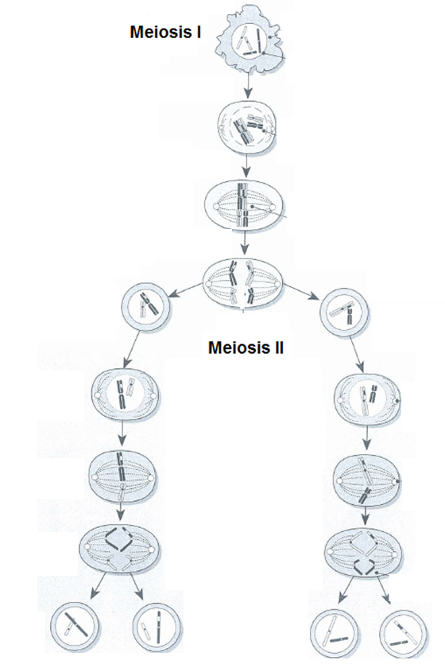

10) **Explain** how random fertilisation contributes to variation. (2 marks)

__________________________________________________________________________________________

__________________________________________________________________________________________

__________________________________________________________________________________________

__________________________________________________________________________________________

11) Write a definition for the term ‘natural selection’. (2 marks)

__________________________________________________________________________________________

__________________________________________________________________________________________

__________________________________________________________________________________________

12) Write a definition for the term ‘mutation. (2 marks)

__________________________________________________________________________________________

__________________________________________________________________________________________

__________________________________________________________________________________________

13) For each main group below, give a specific example of a mutagen. (4 marks)

Ionising radiation: ___________________________________________

Alcohol and diet: ___________________________________________

Viruses and microorganisms: ___________________________________________

Poisons and irritants: ___________________________________________

14) **State** the sex of the individual whose karyotype is shown below. (1 mark)

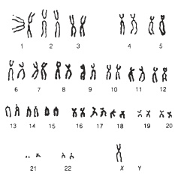_____________________________________________________

b) **State** whether the individual has monosomy or trisomy. **Explain** your answer. (2 marks)

__________________________________________________________________________________________

__________________________________________________________________________________________

__________________________________________________________________________________________

c) **State** the name of the specific mutation that this individual suffers from. (1 mark)

_____________________________________________________

15) **Fill** in the missing spaces. (3 marks)

A person can have large numbers of mutations in their genes but not be aware of them. If that person reproduced with a partner who had the same recessive _____________________, the recessive condition could appear in their ____________________.

Some recessive mutations are lethal if they are not masked by a ___________________ normal allele. These are called ________________________________________.

Two disorders caused by this type of mutation are _________________________ and ______________________.

**PART C: EXTENDED ANSWER**

16)Variation in the human species occurs due to chromosome variation. For each type of chromosome variation listed below, **state** when it occurs, **describe** how it occurs and **list** two examples of disorders caused by the type of variation (only if it causes disorders).

Crossing over, random assortment of chromosomes during meiosis and non-disjunction.

Hint: use a table! (11 marks)

__________________________________________________________________________________________

__________________________________________________________________________________________

__________________________________________________________________________________________

__________________________________________________________________________________________

__________________________________________________________________________________________

__________________________________________________________________________________________

__________________________________________________________________________________________

__________________________________________________________________________________________

__________________________________________________________________________________________

__________________________________________________________________________________________

__________________________________________________________________________________________

__________________________________________________________________________________________

__________________________________________________________________________________________

__________________________________________________________________________________________

__________________________________________________________________________________________

__________________________________________________________________________________________

__________________________________________________________________________________________

__________________________________________________________________________________________

__________________________________________________________________________________________

__________________________________________________________________________________________

__________________________________________________________________________________________

__________________________________________________________________________________________